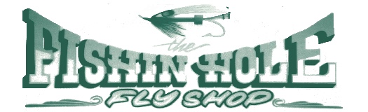

Fly Shop

Raft Rentals

541-878-4000

Deli

Gift & Yarn

541-878-4003 4003

541-878-4003

Our full day, 7-8 hour guided fishing trips include a nice full lunch and drinks from our Deli and all gear is provided, with the exception of flies.

You can expect to typically cover about 13 miles of the river fishing from a drift boat, upon request, you may do some wade fishing as well.

We would love to hear from you! Please give us a call with any questions you might have regarding pricing, peak seasons, types of fish, flies & tackle, weather etc.

Also, keep in mind that we have a fully outfitted shop where you will meet your guide and you can grab any last-minute things you might need!

21873 Hwy 62 Shady Cove, OR 97539

[www.thefishinholeflyshop.com](http://www.thefishinholeflyshop.com)

GUIDED FISHING TRIPS

GUIDED SCENIC TRIPS

Our 4-5 hour guided scenic trips explore approximately 13 miles of the Upper Rogue River starting near Lost Creek Lake & ending in Shady Cove.

You can look forward to class I & II rapids, just big enough to excite but not to scare even the most novice of rafters!

With an abundance of wildlife including Deer, Blue Heron, Osprey, Bald Eagles, Otter & Mink, you’re sure to see more than one! Kick back & enjoy a day on the famous Rogue River, complete with hors d’ oeuvres & drinks from our Deli.

Day trips are booked per client at your chosen time between 8am - 2pm, returning to the shop by 6pm.

Evening trips depart 6pm - 7pm and are most often on full moon evenings.

GIVE US A CALL TO BOOK YOUR TRIP TODAY!!